# Unit 9 Worksheet

* Example 9.1
* Example 9.2
* Example 9.3

### ****Example 9.1****

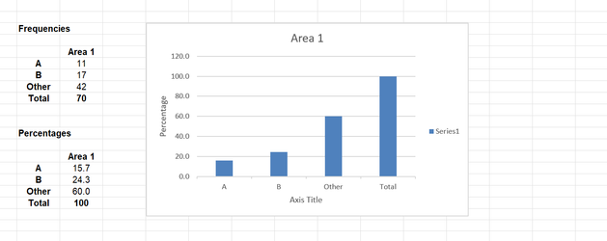

Add a percentage frequency for Area 2.

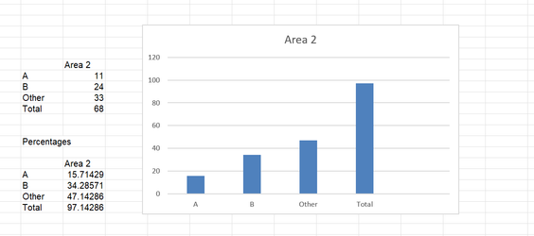

**My findings show that Brand B is preferred in Area 2, and other is preferred in Area 1.**

### ****Example 9.2 – see below****

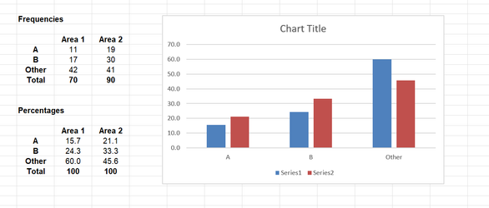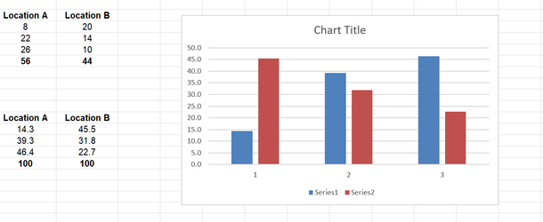

### Example 9.3 – see below

